From:

Fire In The Hole! Why The Eccles Building Should Burn To The Ground
The level of Fed group-think sophistry, circularity and plain old humbug has gotten so bad that there is nothing left to do other than what the British Navy would have done if the Eccles Building had been there in 1812. Namely, burn it to the ground.
These people have become so inebriated with their own misbegotten power to move the multi-ten trillion financial markets of the world that they have literally lost touch with all historic learning about sound finance, as well as with the on-the-ground speculative manias they have unleashed in every nook and cranny of the financial markets and main street economy, alike.
Indeed, to hear them blabber on you’d think they were playing some kind of grand video game. They’ve got the joystick and everything on the screen moves to their command.
And when they order financial asset prices to move, they foolishly presume that the vectors of force they unleash are entirely linear.
That is, if they crank down money market rates 25 basis points, nothing else happens except that “financial conditions” ease, thereby spurring higher financial asset prices on Wall Street and higher confidence and activity on main street. Wealth effects at work!
But even as they attempt to perfect capitalism’s allegedly sloppy, subpar and unstable performance, there are purportedly no adverse feedback loops, unintended consequences or counter-productive signals and behaviors that off-set the goodness of their finely honed interventions.
Yet that is exactly why capitalist prosperity and democratic self-governance is literally dying on the vine. The truth is, the negative consequences, feedbacks and ripple effects of their manic interest rate pegging and bond-buying escapades massively overwhelm and cancel the alleged salutary effects of their Keynesian style central banking.
That’s because the very last thing the state should tamper with is the price of money, debt and other financial assets. In effect, screw around until your hearts content with price controls like the minimum wage, rent ceilings, public utility rate caps, market entry restrictions and crony capitalist bailouts—all of which do considerable harm but are not infectious and fatal.
But don’t monkey around with the financial circulatory system of capitalism. Falsify financial prices—and that’s the sum and substance of what central banks actually do—and you distort and poison the entire body economic.
Way down at the end of the line you get
- consumers bankrupting themselves on cheap debt,
- businesses strip-mining the balance sheets to goose stock prices and
- governments burying future generations in crushing debts because they can finance nearly unlimited borrowing at near, at or below zero.
Yet could our current monetary central planners even consider for even a moment the massive damage they are doing to the financial signaling system of American capitalism or via the vast flows of misdirected capital and malinvestment their interventions inexorably trigger?
They cannot. It would put them out of business!
This utter blindness to the corollary impact of ZIRP, QE, recession insurance and all the other “just in case” nonsense that emanates from the Fed was on full display on bubble vision yesterday.
Indeed, we almost blew a gasket when we saw “Softball Steve” (Liesman) interviewing Fed Vice-Chairman Richard Clarida on CNBC. We rarely have the sound on during these interviews because we know in advance that Liesman pays for his access by never asking about anything which might ixnay the Eccles Building groupthink.
But this time he was so bold as to ask the unavoidably obvious question about the Fed’s $400 billion liquidity pumping spree since the end of September. And that caused Clarida, in turn, to establish that he’s either a mendacious moron or a sniveling coward, as the case may be.
Liesman: Do you worry that with what the Fed has done in terms of inserting a lot of liquidity into the market (Treasury bill buying & repo) has created the recent boom in the stock market?”
Clarida: “I’ll leave that for others to judge”.
C’mon. What hay wagon does this leading member of our monetary politburo think we fell off from?
We are really supposed to look at the chart below—-which tracks the very most important thing happening right now in the entire global financial system and economy—and accept his preposterous claim that the red line has nothing to do with the eruption of the blue line since exactly October 7th. That is, when Pivoting Powell announced the Fed was plunging back into “not QE” barely a year after it had made a belated and tepid effort to start shrinking its elephantine balance sheet.
Stated differently, when you get to the point the Fed heads deny their self-evident subservience to the crybabies and bullies of Wall Street, as has been so blatantly on display since last fall, then, as we say in the title of our post, it is indeed time for the British Navy to revisit the Imperial City.
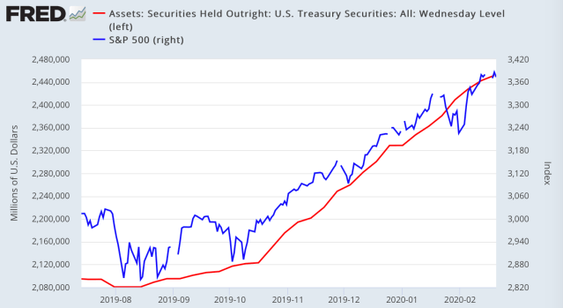
Actually, Clarida’s malarkey is not the half of it. He no sooner got done with his blind, deaf and dumb routine than one of the worst Keynesian lifers at the Eccles Building, Lael Brainard, came out for “inflation averaging”.
She did so on the grounds that even, presumably, a 0.20% shortfall from the Fed’s 2.00% inflation target in any given year is economically fatal and must be recouped by letting inflation running hotter than 2.00% for however long it takes to catch up.
The purpose, evidently, is to insure that the price level will be precisely, predictably and unfailingly 1000% higher a century from now so that inflation expectations will be well anchored. Per today’s news crawler:
An influential member of the Federal Reserve’s board of governors has called for the central bank to set temporary inflation targets above its current goal of 2 per cent, to make up for periods when inflation runs below target.
In remarks at the US Monetary Policy Forum in New York on Friday, Fed governor Lael Brainard referred to this policy as “flexible inflation averaging”.
The comments offer the clearest sign yet that the Fed intends to re-examine how its monetary policy committee approaches its inflation target, as it prepares to release conclusions from an 18-month policy review this summer
“By committing to achieve inflation outcomes that average 2 per cent over time, the committee would make clear in advance that it would accommodate rather than offset modest upward pressures to inflation in what could be described as a process of opportunistic reflation,” she said.
We will beat the horse of 2.00% inflation targeting on another occasion, but here is the path since inflation targeting was adopted in January 2012.
Put 1,000 monkeys (economists) in a room full of typewriters (Cray computers) for a thousand years (exabytes) and they still will not explain (compute) why the PCE deflator is right and the 16% trimmed mean CPI is wrong or why the tiny gap between the two makes any difference anyway.
And that’s to saying nothing about justifying in the first place why 2.00% inflation is so important that it requires massive falsification of financial asset prices by the central banks.
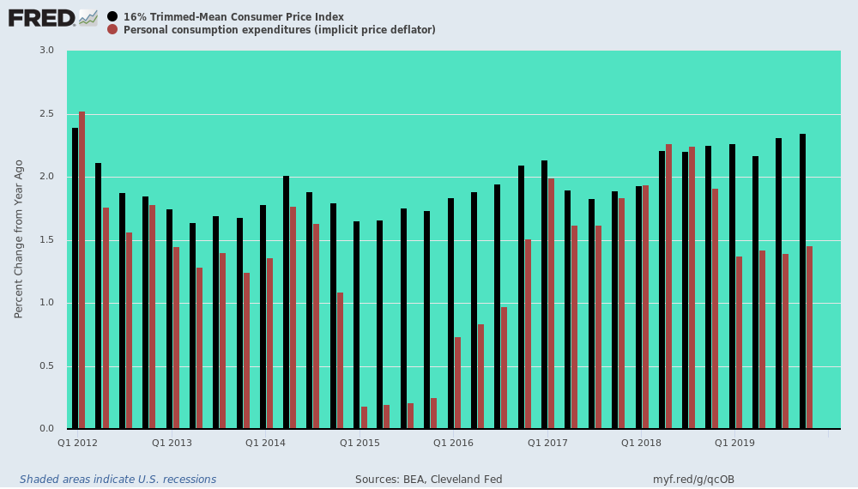
Finally, this morning there was St Louis Fed head James Bullard taking his turn on bubble vision. And again, Steve Liesman stumbled into another good one while discussing the very absurdity that the Fed should cut interest rates to fight Covid-19:
Liesman: “How would a quarter-point rate-cut ‘cure the flu’?”
Bullard: “…well, you know, you get a cold and you maybe drink more orange juice than you would otherwise… does that cure the cold? Probably not…but it treats some of the symptoms… so I think it might help a little bit.”
In other words, there is no downside to flooding Wall Street with massive flows of cheap carry trade funding and it might do some good. Call it the monetary bleeding cure.
In fact, heavy-handed tampering with financial asset prices will do immense, systemic harm, but absolutely nothing (even at the margin) to improve global supply chains, or increase consumption, or ‘juice’ the economy. As Zero Hedge noted,
…they are merely a placebo – a promise to keep the ponzi alive for one more quarter at any and all costs because – as is now clearly obvious – nothing else matters but keeping asset prices high (or higher), most especially the US stock market.
Still, being the expert virologist that he is, Bullard assured the viewing mullets that Covid-19 will blow over in a jiffy. No harm, no foul:
“There’s a high probability that the coronavirus will blow over, as other viruses have, be a temporary shock and everything will come back,” he said, offering absolutely no evidence.
But of all Bullard’s canards, this one was priceless:
The idea that 60% of GDP is the limit, and that seems to be out the window. Doomsday scenarios about, you know, carrying too much debt don’t seem to be working. So, I think as macro-economists, it’s incumbent upon us to get more granular and serious about what we’re going to say about government debt. Because I think to say the sky is falling all the time hasn’t been working.
Truly, thems the words of the little boy who killed his parents and then plead the court for mercy on the grounds that he was an orphan!
The public debt has soared from $5.5 trillion in the year 2000 to $23 trillion at present (and rising rapidly) without a huge dislocation to date because the Fed and other central banks have driven interest rates to rock bottom and have monetized on a worldwide basis upwards of $22 trillion of debt securities since the turn of the century.
That do make one helluva difference in the short-run, even if it leads to the same doomsday eventually.
For example, the public debt has grown by a staggering 294% since January 2000, but that has resulted in only a 65% rise in Federal interest expense. In a steady-state world, of course, both would rise at the same rate.
But in the short run that horribly faulty juxtaposition told politicians not to sweat the red ink and traders in the bond pits that central banks would evacuate the public debt. So rather than facing the crowding out effect with rising yields and falling bond prices, which would be the natural order of things, they were incentivized in just the opposite direction.
To wit, to front-run the central banks and to buy what they were loudly and publicly committed to purchase and to do so on practically zero cost repo funding, which was the money market consequence of pegging the policy rate near, at or below the zero bound.
The result was that the sovereign debt market was turned into a highly leveraged gambling casino, where speculators chased rising prices and pocketed persistent capital gains in what is supposed to be an arena offering modest coupon income and minimal price change.
Yet smart-alecky Bullard has the nerve to say that deficit hawks should go back to the drawing boards because the Fed has put its big fat thumb on the scales of supply, demand and price.
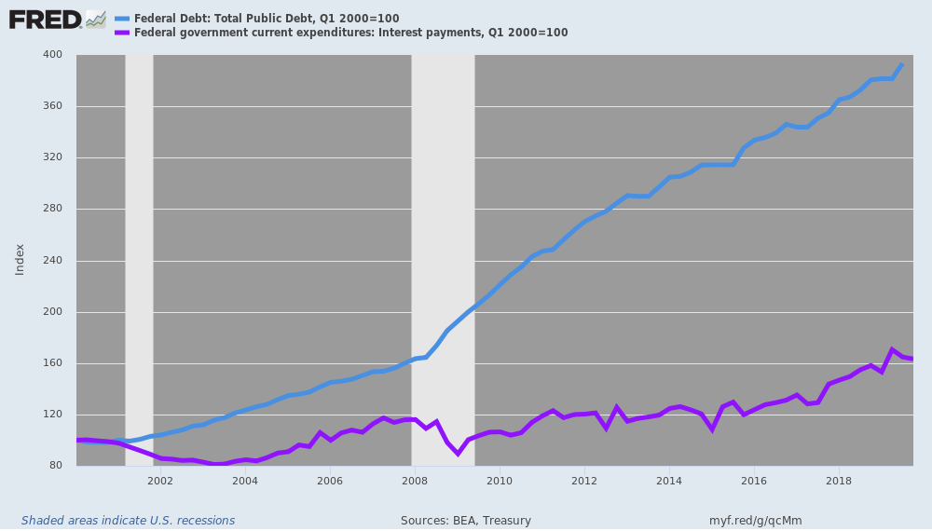
Nor was Bullard done displaying his contempt for sound finance during this morning’s CNBC blathering session. He also plunged right into unbelievable circularity by claiming there are no bubbles in a market that is rife with them because interest rates are so low that current nosebleed PE multiples are both appropriate and un-concerning:
We always watch this, and we watch financial stability issues and bubble type issues very carefully.
I think the conventional wisdom is that valuations look high, but not at this level of interest rates. And so, to the extent you think this level of interest rates is probably the future, which I’ve been arguing, I think we’re okay for now.
Wow!
The Fed and its fellow-traveling central banks around the world have fueled an insane bond bubble that at this very moment is being crystalized by $16 trillion of bonds trading at subzero yields.
Yet this moron—and there is no kinder description of Bullard gray matter (or lack thereof)—says there is no stock market bubble because, well, one bubble begets another.
The chart below sets the current interest rate madness in historical perspective. Until the Greenspan housing/mortgage bubble collapsed in 2008, the green line (10-year US treasury yield) was always 200-400 basis points above the inflation rate (red line).
Possibly even an exalted Fed head might have heard that long-term bond investors need to get their money back after inflation has taken its toll—plus a return for risk and the time value of money.
As it evident in the right panel, benchmark bond yields have been driven cheek-by-jowl to the inflation rate and frequently below ever since the economy recovered in 2009-2011. And this very morning as Bullard bull-shat away on CNBC, the 10-year UST up on the screen was yielding 1.48% against a just reported year-over-year inflation rate for January which posted at 2.41%.
That’s right. This cat says to price stocks off totally manipulated and repressed bond prices, which are now trading at a negative -93 basis points of real yield. Moreover, by Bullard’s lights such ridiculously sub-economic yields “are probably the future”.
In short, the level of malign group think and self-reinforcing delusion is so deeply embedded in the Eccles Building that we probably do have no alternative except to call in the British Navy.
